Gastrointestinal agents (Acidifiers)
- Acidifiers are inorganic chemicals that either produce or become acid.
- These chemicals increase the level of gastric acid in the stomach when ingested, thus decreasing the stomach pH.
- These are many types of acidifiers but the main four types are:
  - Gastric acidifiers, used in controlling pH in stomach.
- Urinary acidifiers, used in controlling pH in urine.
- Systemic acidifiers, used in controlling pH in all the parts of body.

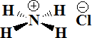
•

ACHLORHYDRIA:
Refer to states where the production of hydrochloric acid in gastric secretions of the stomach and other digestive organs is absent or low, respectively. It is associated with various other medical problems
Since acidic pH facilitates the absorption of iron, achlorhydric patients often develop iron deficiency anemia. Acidic environment of stomach helps conversion of pepsinogen into pepsin, which is highly important in digesting the protein into smaller components, such as a complex protein into simple peptides and amino acids inside the stomach, which are later absorbed by the gastrointestinal tract.
Bacterial overgrowth and B12 deficiency (pernicious anemia) can cause micronutrient deficiencies that result in various clinical neurological manifestations, including visual changes, paresthesias, ataxia, limb weakness, gait disturbance, memory defects, hallucinations and personality and mood change.
Even without bacterial overgrowth, low stomach acid (high pH) can lead to nutritional deficiencies through decreased absorption of basic electrolytes (magnesium, zinc, etc.) and vitamins (including vitamin C, vitamin K, and the B complex of vitamins). Such deficiencies may be involved in the development of a wide range of pathologies, from fairly benign neuromuscular issues to life-threatening diseases.
In patients suffering from achlorhydria, there is deficient secretion of HCl in stomach. In such cases acidifiers are useful in providing the necessary acidity for the proper digestion of food. Systemic acidifiers are those which, when given usually by injection, act by reducing the alkali reserve in the body and are also useful in reducing metabolic alkaloids.

CAUSES
- The slowing of the body's basal metabolic rate associated with hypothyroidism
- Pernicious anemia where there is antibody production against parietal cells which normally produce gastric acid.

- The use of antacids or drugs that decrease gastric acid production (such as H2- receptor antagonists) or transport (such as proton pump inhibitors).
- A symptom of Helicobacter pylori infection which neutralizes and decreases secretion of gastric acid to aid its survival in the stomach.
- A symptom of atrophic gastritis or of stomach cancer.
- Radiation therapy involving the stomach.
- Gastric bypass procedures such as a duodenal switch , where the largest acid producing parts of the stomach are either removed, or blinded.
- Pellagra, caused by niacin deficiency.
- Chloride, sodium, potassium, zinc and/or iodine deficiency, as these elements are needed to produce adequate levels of stomach acid (HCl).

Treatment
Treatment focuses on addressing the underlying cause of symptoms.
- Treatment of gastritis that leads to pernicious anemia consists of parenteral vitamin B-
12 injection. Associated immune-mediated conditions (e.g., insulin-dependent diabetes mellitus, autoimmune thyroiditis) should also be treated. However, treatment of these disorders has no known effect in the treatment of achlorhydria.
- Achlorhydria associated with Helicobacter pylori infection may respond to H. pylori eradication therapy, although resumption of gastric acid secretion may only be partial and it may not always reverse the condition completely.
- Antimicrobial agents, including metronidazole, amoxicillin/clavulanate potassium, ciprofloxacin, and rifaximin, can be used to treat bacterial overgrowth.
- Achlorhydria resulting from long-term proton-pump inhibitor (PPI) use may be treated by dose reduction or withdrawal of the PPI.
- Diluted HCl solution

Laxatives
Laxatives, purgatives, or cathartics are substances that loosen stools and increase bowel movements. They are used to treat and/or prevent constipation.
Constipation is the infrequent or difficult evacuation of the faeces.

Cathartics are used:
  - To ease defecation in patients with painful haemorrhoids or other rectal disorders and to avoid
  - Excessive straining and concurrent increase in abdominal pressure in patients with hernias Or

  - To avoid potentially hazardous rise in B.P. during defecation in patients with hypertension,
  - To relieve acute constipation Or
  - To remove solid material from intestinal tract prior to certain roentgenographic studies.
- Laxative should only be used for short term therapy as prolonged use may lead to loss of spontaneous bowl rhythm upon which normal evacuation depends, causing patient to become dependent on laxatives, the so called laxative effect.

Three types of laxatives are known:
  - Laxative or aperient: Milder action, elimination of soft but formed stools.
Onset of action: 12-72 hours.
  - Purgative: Purgative are moderate laxative.
Onset of action: 6-8 hours.
  - Cathartic: Stronger action resulting in more fluid evacuation.
Onset of action: 0.5-3 hours (oral), 2-15 minutes (rectal)

Classification:
    - Bulk forming: Dietary fibre: Ispaghula (Plantago), Methylcellulose
- Stool softener: Docusates (DOSS), Liquid paraffin
  - Stimulant purgatives: Senna, Sodium picosulfate, Castor oil
  - Osmotic purgatives [Saline (Osmotic) Cathartics]: Magnesium salts: sulfate, hydroxide; Sodium salts: sulfate, phosphate; Sod. Pot. tartrate;Lactulose

Mechanism of Action:
All purgatives increase the water content of faeces by:
  - A hydrophilic or osmotic action, retaining water and electrolytes in the intestinal lumen-increase volume ofcolonic content and make it easily propelled.
  - Acting on intestinal mucosa, decrease net absorption of water and electrolyte; intestinal transit is enhanced indirectly by the fluid bulk.
  - Increasing propulsive activity as primary action-allowing less time for absorption of salt and water as asecondary effect.

Saline Cathartic or Irritant laxatives exert an irritant action on the intestinal mucosa. This causes less fluid to be absorbed than is secreted. This filling of the intestinal lumen stimulates reflex peristalsis. Peristalsis is also directly simulated by the irritant action. | Bulk laxatives  are insoluble and nonabsorbable from the intestine.  They absorb water and expand within the intestinal lumen; this stimulates peristalsis.

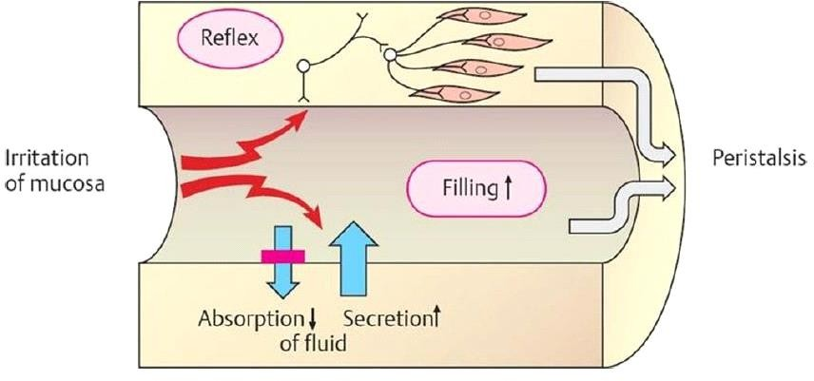
❖ Magnesium Sulphate
- Molecular  formula | MgSO4 • 7H2O
- Uses: It is used as osmotic laxative (Saline Cathartics), in treatment of electrolyte deficiency, in wet dressingin boils, in treatment of cholecystitis, sea sickness,
- Storage: Kept in tightly closed-container
- Dose: 10-15g/day

